**Part A**

1.

3.

4.

5.

The order of table removal is crucial because foreign keys must reference primary keys to establish a match. As the screenshot shown, if I try to remove a table (movies / actors) that has a primary key referenced by a foreign key in another table (castings), I will get an error.

**Part B**

6.



7.

8.

9.

10.

After I delete all the employeecopy data, when I try to use SELECT statement to display all the data from employeecopy table, there is no data shown as the screenshot shown, but the employeecopy table still exist and have the constraints come from retailemployees. I can easily delete the table by using DROP statement.



11.

12.

13.



14.

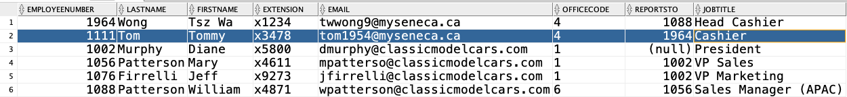

15.

No, it didn’t work, since the reportsto column in the retailemployees table is a foreign key that references the employeenumber column, which is the primary key in the same table. Deleting a row that has a foreign key reference can violate referential integrity

16.

Yes, it works.

17.

18.

19.

20.

